Four and Six-Figure Grid References
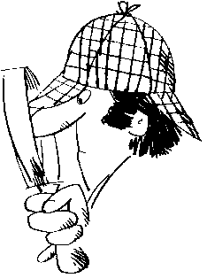

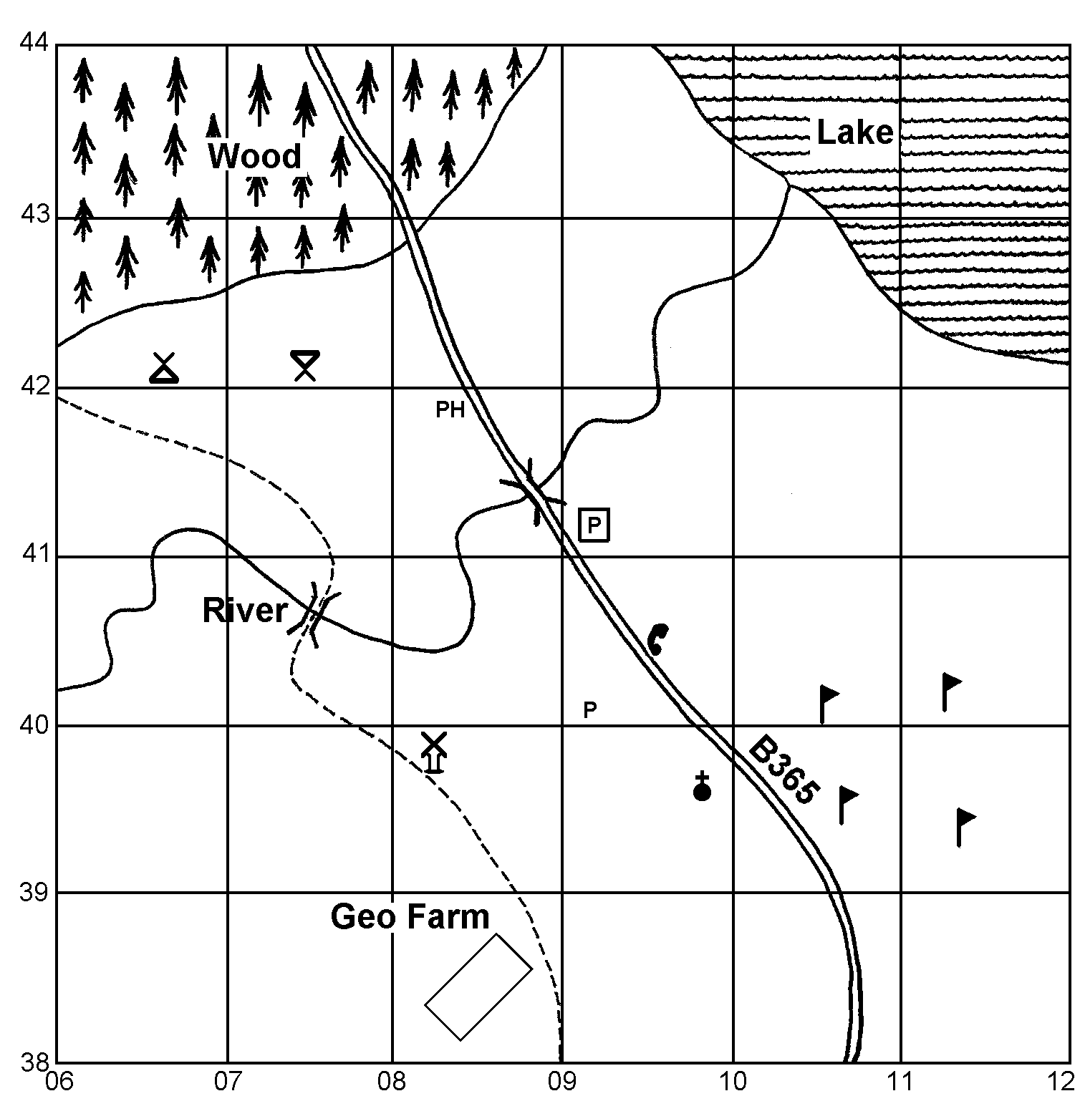

Legend:
 Wood
 Lake
 Secondary
Road
 Bridge
Camp Site
Car park
Picnic Site
PH Public House
P Post Office
Golf Course
 Place of worship
with spire
Public Telephone
Windmill

1. Give a 4-figure grid reference to locate the lake ________________.
2. Give a 4-figure grid reference to locate part of the wood ________________.
3. Give a 4-figure grid reference for a bridge ________________.
4. Give a 4-figure grid reference containing part of the golf course ________________.

5. Answer: windmill, car park, place of worship with spire, picnic site, camp site or public house to the following questions:
(a) The is in square 0839. | (b) The is in square 0841.
(c) The is in square 0742. | (d) The is in square 0941.

6. Give the 6-figure grid references for the following:
(a) Camp site: | (b) Picnic site: |  | (c) Post office:
(d) Parking: | (e) Windmill: |  | (f) Public house:
(g) Place of worship with spire: |  | (h) Public telephone:
Four and Six-Figure Grid References

Answers

- Any one of the following:
0943
1042
1043
1142
1143

- Any one of the following:
0642
0643
0742
0743
0843

- Any one of the following:
0841
0740

- Any one of the following:
1039
1040
1139
1140

- a) Windmill
b) Public House
c) Picnic Site
d) Parking

- a) 066421or 067421
b) 074421 or 075421
c) 091401
d) 092411 or 092412
e) 082399
f) 083419
g) 098399
h) 095405 or 096405

